Hazratbal-Srinagar-06 (J&K)
Ist December, 2020

Esteemed Colleagues, Collaborators & Friends

Greetings from NIT Srinagar

The 7th edition of biennial International Conference on Nanotechnology for Better Living (NBL-21) is being organized by National Institute of Technology Srinagar under the aegis of Materials Research Society of India (MRSI) in association with Anna University, SKUAST-K, NIT Mizoram, SSM College of Engineering, IIT Madras, Higher Education and many more institutions from 07-11 April, 2021, which marks the birth anniversary of a famous microbiologist Prof. James Watson- all rolled in one. The scientific event is expected to provide a vibrant platform to present and discuss path breaking research ideas in nanotechnologies and shall be an interface between academia and industries. The event being organized during the worst pandemic, which is our common sorrow and common pain, will mostly focus on “Nano-Coatings and Nano-sprays for infectious and inflammatory diseases”, nevertheless limited to and shall be a fabulous fusion of biological, chemical, physical, natural, agricultural, medical and engineering sciences.

There is also need to develop young minds and providing them such forums will help them to implement their thoughts and find innovative solutions for dreadful issues threatening bold the world. We have made arrangements for the pre-conference tutorials for our bright students who are supposed to work on innovative projects in their final year as envisaged in New Education Policy, thus handing over this new and multidisciplinary science to young generation, of which Einstein have made mention. We are proud and privileged to mention that an Indian origin schoolgirl aged 11 has been honoured as "America's top young scientist" for inventing a quick, low-cost test to detect lead-contaminated water, using carbon nanotubes”, is an inspiration for all of us. Likely, Anika recently takes home top prize for developing a novel antiviral drug to combat the spread of COVID-19 by researching protein spikes in coronavirus.

We are optimistic and hopeful to have relief from the wide spread of SARS-COV-2 (Covid-19) in summer; the event will be held off-line in SKUAST, Shalimar Kashmir, though zoom option can’t be ruled out at this preliminary stage. The dates coincide with the blossom of Tulip flowers in Kashmir and we are confident that many stalwarts of Nanosciences may join us during the programme and provide a multidisciplinary platform in this paradise. It is pertinent to mention that the event is being organized in the backdrop of NBL series, which were marvelous and memorable joint event between IIT Kanpur/IIT Kharagpur under the Co-chair of Prof. Kamal K Kar, Prof. Pallab Banerji and Prof. R Mukherjee, whose partisanship will continue.

I am attaching a brochure of the scientific event; the necessary details are mentioned in brief and deadline has been fixed as 30th January 2021 for Extended Abstract Submission. Shall you have any questions, please do not hesitate to drop a mail at shahji@nitsri.ac.in and never hang back to reach me through my hand Set:- +91-9419018195. I look forward for your kind co-operation in forwarding this information to your colleagues, students and friends for wide circulation and for participation thereof in this sacred place of saints.
With very best regards

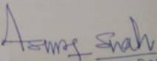
Dr. M. A. Shah Convener, ICNBL-21/ PI-Nano-Mission Project
www.icnbl.org/www.nitsri.ac.in/shahnit.org

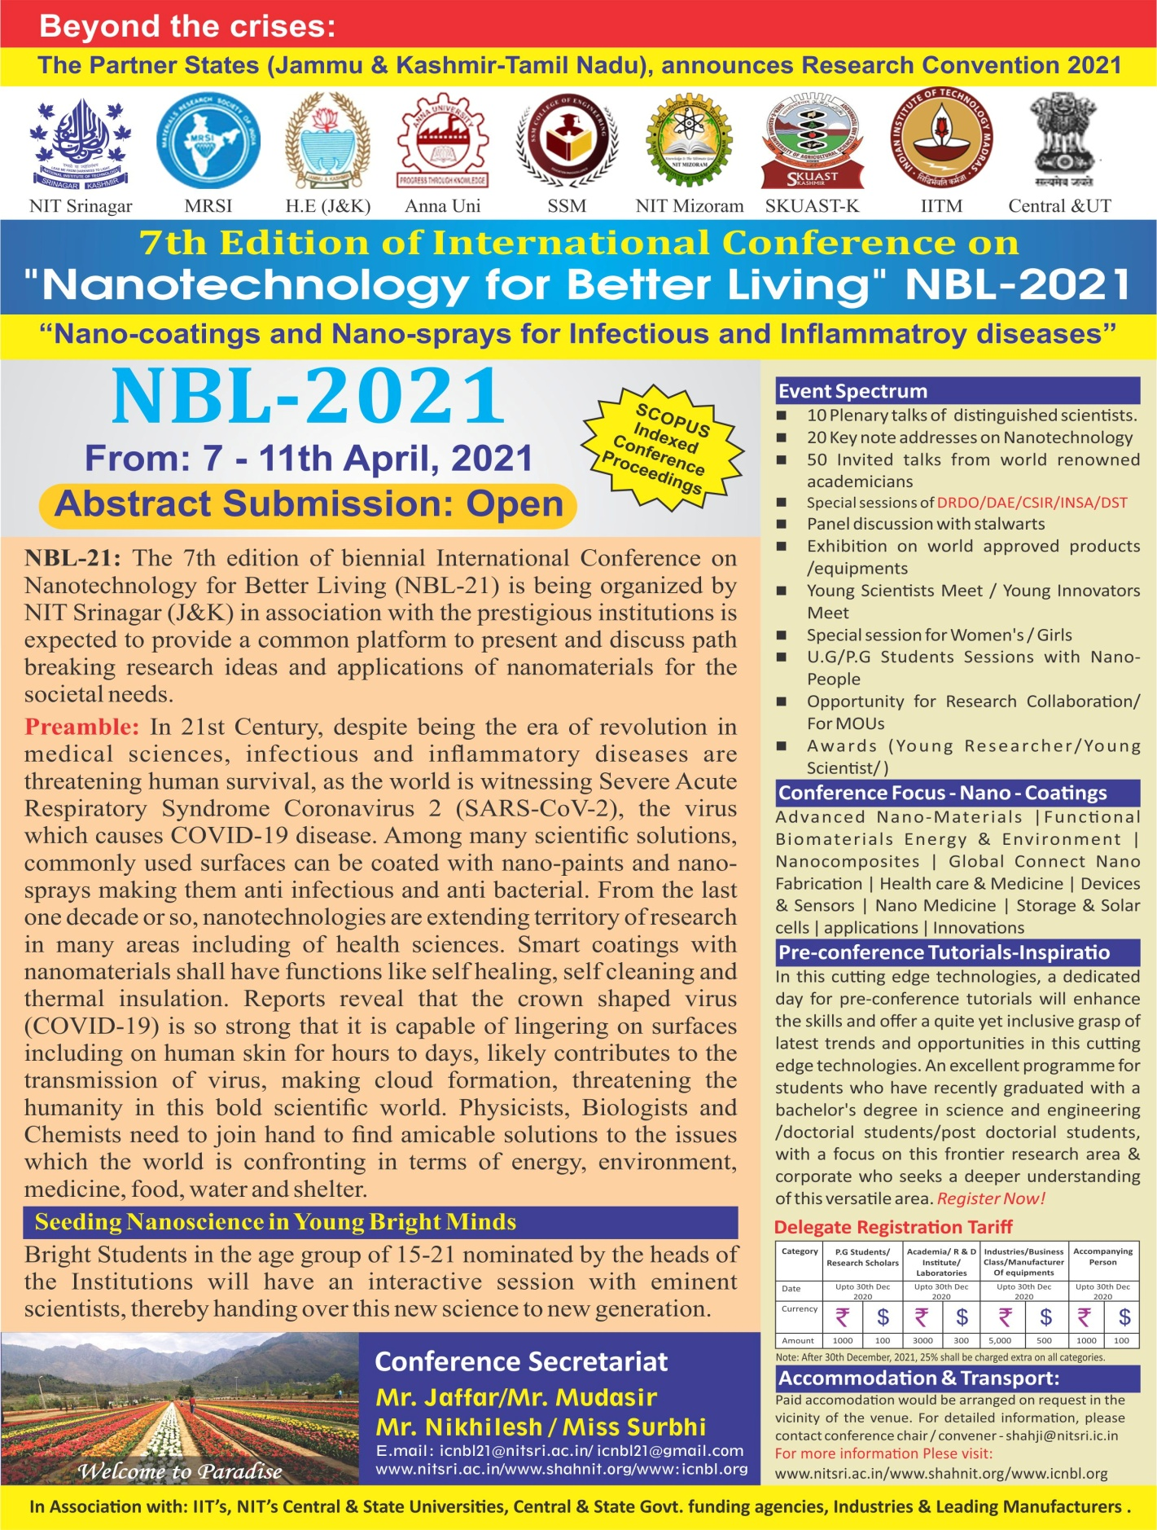

O Lord, we come this morning Knee-bowed and body-bent
Before Thy throne of grace O Lord—this morning—

Extended Abstract Format at web page- www.icnbl.org

