Instructions:
- If your organization does not have a designated social media page, kindly share these posts on the handles/ Facebook pages of your organization heads, official members, etc.
- The Social media content is for Facebook and Twitter, but can be used on all platforms and mediums which would be help create awareness about GOAL program: Digital Posters, In Emails, etc.
- Request you to make sure that the GOAL Facebook Page (@GOAL-Going Online As Leaders) and Ministry of Tribal Affairs Facebook Page (@Ministry of Tribal Affairs) are tagged in all Facebook post
- Request you to make sure that the GOAL Twitter handle @GOALFacebook is tagged in all twitter posts

Tweets for Universities and Institutes:
- For Mentors
- Become a #GOALmentor and empower tribal youth to become a digital leader – Let us come together to digitally empower tribal youth in times of COVID-19 pandemic! Visit and apply as a mentor today at #GOAL portal http://goal.tribal.gov.in/ @TribalAffairsIn @Facebook

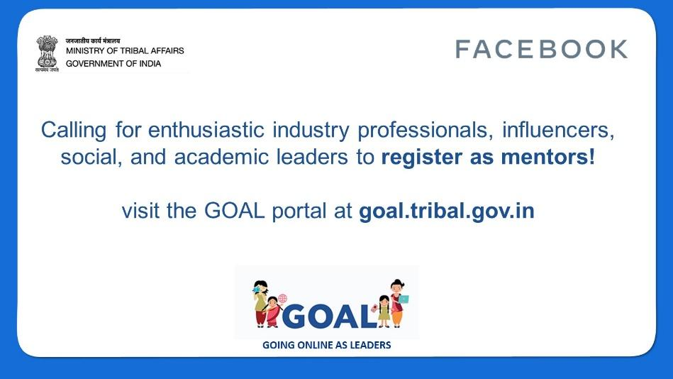

- Calling in all professors, teachers and students across all fields to apply today at #GOAL website http://goal.tribal.gov.in/ to become a mentor. Empower tribal youth by educating them in times of COVID-19 pandemic. Do your bit! #GOALmentor

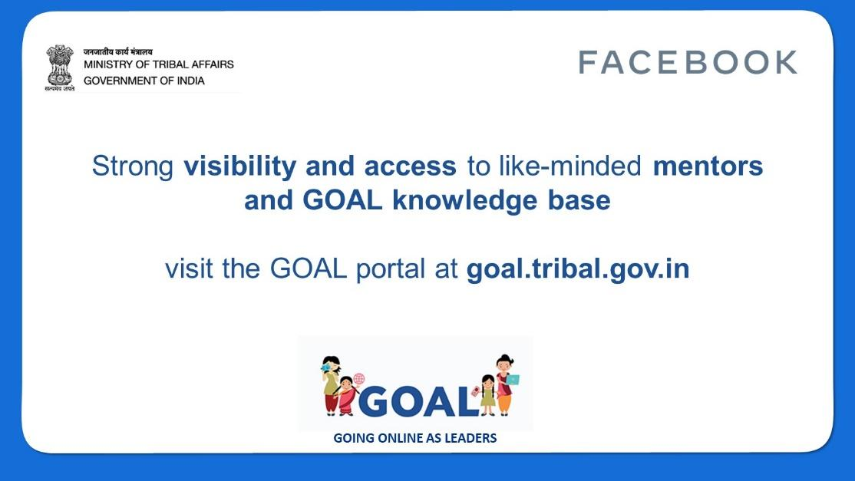

- For Mentees

- Calling all Students from Scheduled Tribe communities to enroll in #GOAL (Going online as leaders) mentorship program an initiative launched by Ministry of Tribal Affairs along with @Facebook. Apply on #GOAL portal http://#GOAL.tribal.gov.in/. #GOALmentee
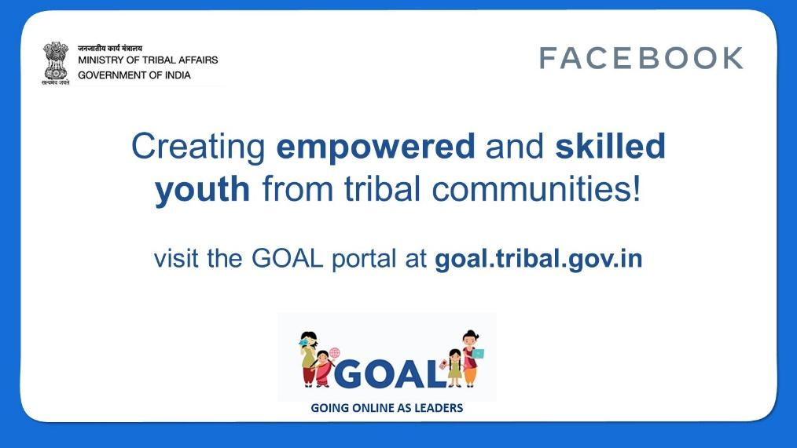
- #GOAL seeks to nurture and train tribal youth across India's tribal heartland, mentorship in digital literacy, life skills, leadership and entrepreneurship. Visit the #GOAL website http://#GOAL.tribal.gov.in/. Tribal youth apply now! #GOALmentee #IsupportGOAL
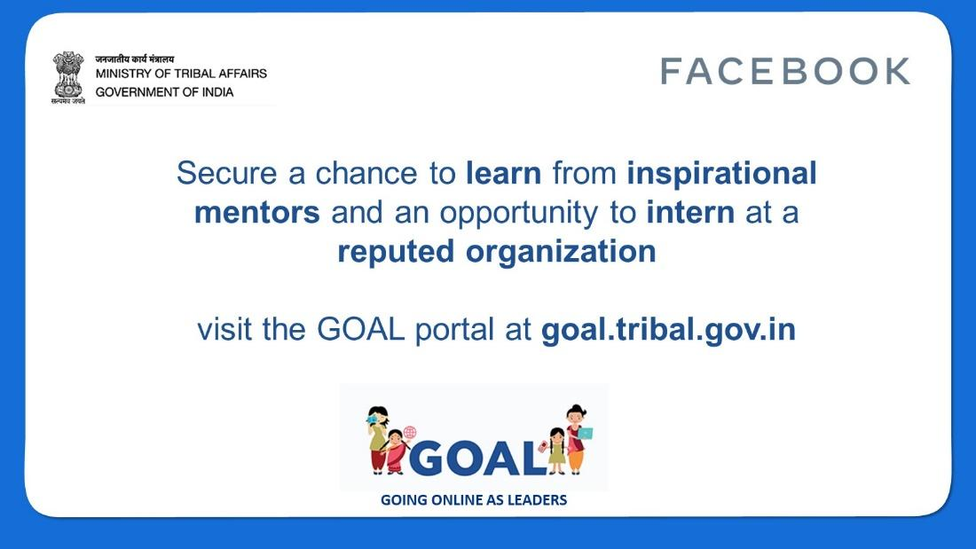
- Aspiring entrepreneurs from tribal communities, apply on http://#GOAL.tribal.gov.in/ for a 7-month one-to-one session with business and industry experts to become successful entrepreneurs of your community! A @TribalAffairsIn and @Facebook initiative #GOALmentee
